Assignment 3: Programming Concepts for NLP and Transformer Implementation (Part 2)
CSC 492/592: Large Language Models

Instructions
Go through each part of the assignment and follow the instructions. Write your answers to all questions in a separate word or pdf document.
Part 0: Transformer Concept Questions
Answer the following questions assuming that our Transformer architecture does not have positional encoding, one head and only uses standard $Q$, $K$ and $V$ matrices (i.e., none of the additional components mentioned in Lecture 3 Part 2 slides are present).
Question 1: Draw a diagram that shows how the input sentence “Go to the river bank” would be converted from a word representation to a numerical representation? Assume that the dictionary size is 50,000 and the embedding dimension is 768. Make sure you label the dimensions of all matrices in the diagram. How many trainable parameters are in this part of the Transformer?

Question 2: Draw a diagram that shows how the output matrices $Q$, $K$ and $V$ are computed. Also show the calculations for computing the attention $A$ and output of the layer. Assume one head, 512 words per input and an embedding dimension is 768. Make sure you label the dimensions of all matrices in the diagram.

Question 3: Consider the architecture diagram you wrote for the input in Question 1 (converting words to numeric representations) and the $Q$, $K$ and $V$ matrix computations diagram you wrote in Question 2. Consider our first input as “go to the river bank and swim” and the second input as “bank on the fact we will win”.

Part A: What would the dimensions of $Q, K and V$ be for these inputs?
Part B: Would the $Q$ representation of the word “bank” be the same for the first input the second input? Explain why or why not. What about for the $K$ and $V$ representations?

Question 4: Your friend Bob was sleeping in LLM lecture and not paying attention. He later wrote the computations for one Transformer layer as $Q=x×W_{Q}$, $K=x×W_{K}$, $V=x×W_{V}$. Bob then mistakenly wrote the attention and output calculations as $A=K×V^{T}$ and $out=A×Q$. Explain why the ‘Bob Transformer’ would or would not be as effective as a standard Transformer?

Question 5: In lecture we covered the concepts of binary and sinusoidal positional encoding. Assume that we have an embedding dimension of 3 and we have 10 words in our input. Could binary encoding be used to create the necessary number of unique position vectors? Explain why or why not? Hint: It may be useful to first write out all possible vectors that can be represented with 3 bits.

Part B: Would binary encoding be able to create enough unique positional encodings vectors when our embedding dimension is 512 and the number of words in our input is 1024?
ANSWERS:
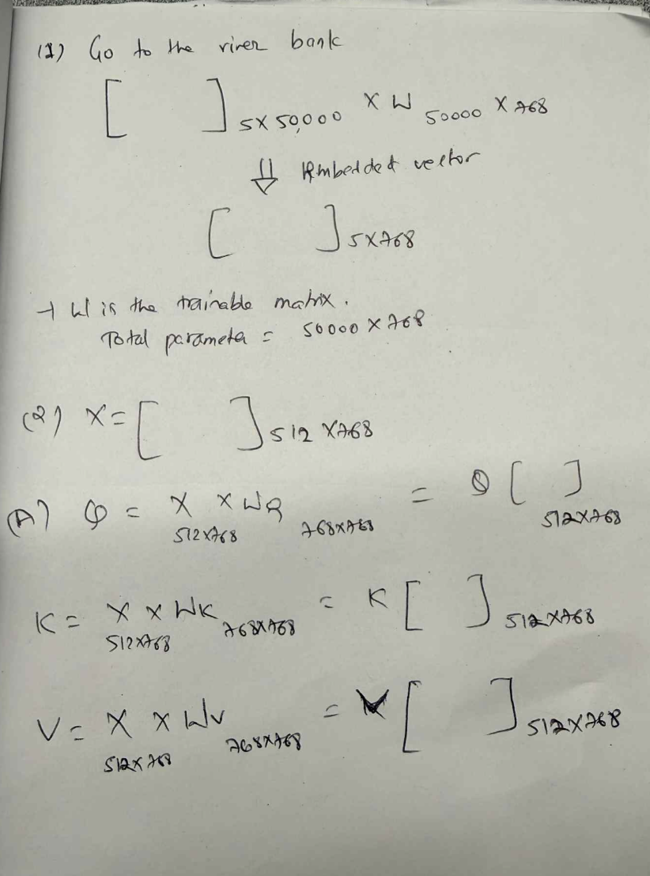

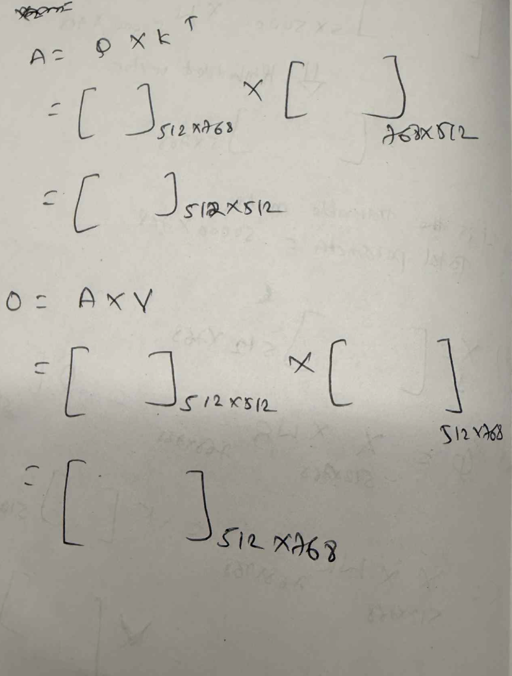

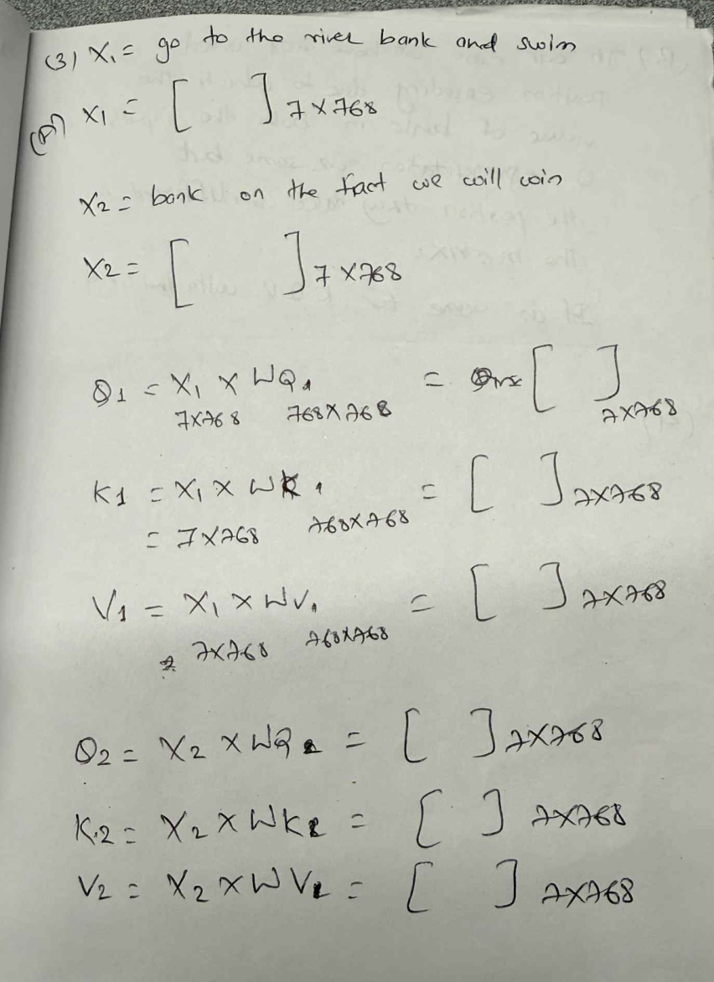

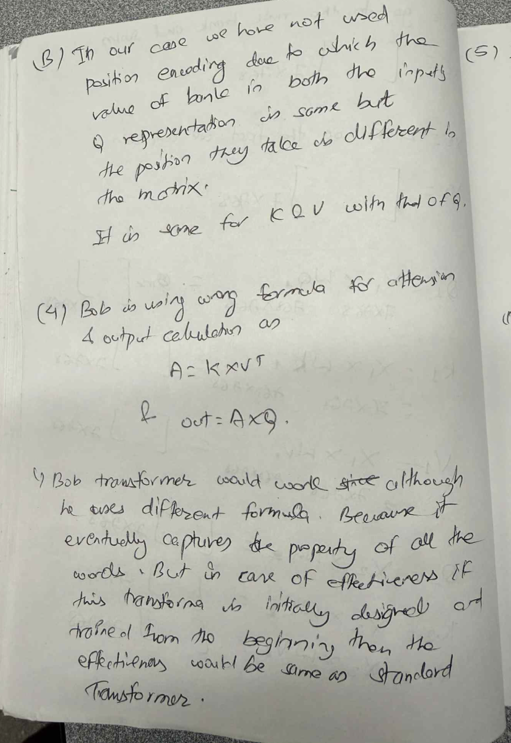
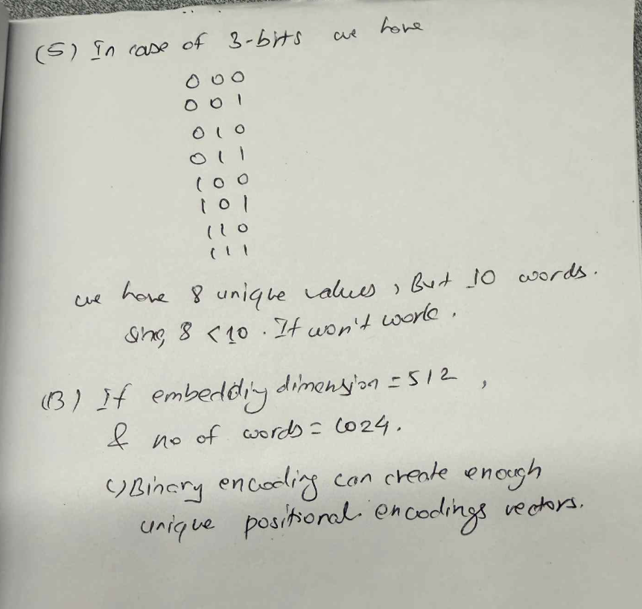
Part 1: Multi-head Attention
Create a Python application called TransformerT2. Add a Python module to it called TransformerLayer.py. Then type the following code in it:
import sys
import torch
from torch import nn
from einops import rearrange

class TransformerLayer(nn.Module):
def __init__(self, d) -> None:
super().__init__()

self.qkv = nn.Linear(d, d*3)
self.wo = nn.Linear(d, d)

def forward(self,x):
x = self.qkv(x)
q,k,v = tuple(rearrange(x,'b n (k d h)->k b h n d',k=3,h=8))
attn = torch.einsum('b h i k, b h j k->b h i j',q,k)
out = torch.einsum('b h i k, b h k j->b h i j',attn,v)
out = rearrange(out,'b h n d->b n (h d)')
print(out.shape)
out = self.wo(out)
return out

def main():
net = TransformerLayer(512)
x = torch.rand((4,100,512))
z = net(x)
print(z.shape)

if __name__ == "__main__":
sys.exit(int(main() or 0))

Run the above code and then answer the following questions.

Question 6: How many heads are in the code for this Transformer architecture? What size embedding does each head operate on?
- Head = 8, embedding = 512/8 = 64

Question 7: If we changed the number of heads in this code to be 32, what embedding size would each head operate on?
- H = 32, embedding = 512/32 = 16

Question 8: What size does the last projection matrix operation (wo in the code) take as input? What is the output?
- Out has a shape torch.Size([4, 100, 512]) before passing to wo, and it defines the linear network as self.wo = nn.Linear(512, 512)

Part 2: Layer Normalization
In the implementation of the transformer, we also use LayerNorm to normalize the data along the embedding dimension. To understand what exactly layer norm does, add a file called LayerNormTest.py with the following code in it.
import sys
import torch
import numpy as np

class NNLN(torch.nn.Module):
def __init__(self) -> None:
super().__init__()
self.LN = torch.nn.LayerNorm(4)

def forward(self, x):
out = self.LN(x)
return out

def main():
x1 = np.arange(4)
d = torch.arange(4).float()
print(d)
x = d.view(1,-1)
net = NNLN()
z = net(x)
print(z)
#TODO: Write a simple code that computes the layer normalization

if __name__ == "__main__":
sys.exit(int(main() or 0))

Run the above code and then answer the following questions.

Question 9: Write a simple code (without using the PyTorch layer normalization function) that takes the data x1 and returns the layer normalized tensor? Hint: The output of your code should match that above the code for at least 3 decimal places.
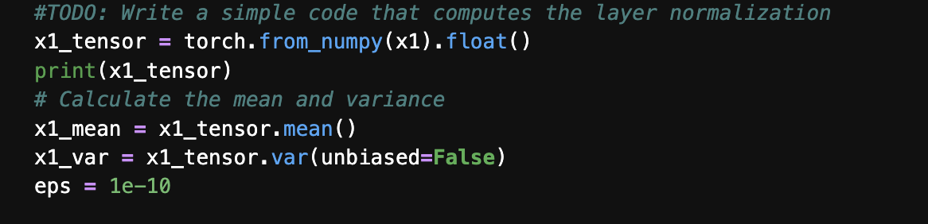

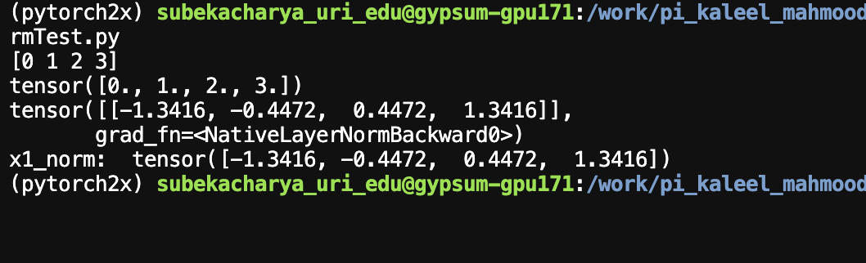
Part 3: Loss Functions
For Transformer implementations, we train the model to minimize a certain loss function. Often we use the cross-entropy loss which is defined as:
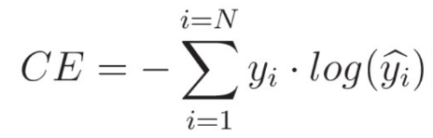
Where $N$ is the number of classes and $\hat{y}$ is the actual output and $y$ is the target output.
Pytorch also defines negative log likelihood loss which is similar to cross entropy. To get a better understanding of the loss function, add a file called CrossEntropyTest.py with the following code in it:
import sys
import numpy as np
import torch

def main():
# assume 3 outputs and batch size of 2, so logits = 2x3 tensor
logits=torch.tensor([[1,3.0,5],[2,4.0,1]])
# above indicates predicted output is 2 and 1 (index of highest value)
print('-----logits--------')
print(logits)

targets=torch.tensor([2,0])
# targets are specified as long, i.e.,
# index of which output is to be recognized, try with [2,1] to see if loss decreases
# pytorch's cross entropy loss, operates on logits (not on softmax layer)
loss = torch.nn.functional.cross_entropy(logits,targets)
print('\ncross entropy loss by pytorch=', loss)

# pytorch's nll_loss (negative log likelihood loss) is similar to cross entropy
# it operates on log_softmax, rather than raw logits
outs = torch.softmax(logits,dim=1)
print('-----softmax------')
print(outs)
outs2 = torch.nn.functional.log_softmax(logits, dim=1)
loss_nll = torch.nn.functional.nll_loss(outs2,targets)
print('nll loss by pytorch =',loss_nll)

# compute cross entropy ourselves
z = (np.log(outs[0,targets[0]]) + np.log(outs[1,targets[1]]))/2
print("\ncross entropy by our calculation=",-z)

if __name__ == "__main__":
sys.exit(int(main() or 0))

Run the above code one time to see the output. Then answer the following questions.

Question 10: Change the targets in the above code from “targets=torch.tensor([2,0])” to “targets=torch.tensor([2,1])”. What happens to the loss value when you do this? Why?
- When we change the targets in the above code from “targets=torch.tensor([2,0])” to “targets=torch.tensor([2,1])” loss function decreases because prediction and target value matches for second sample which causes the loss function to decrease.

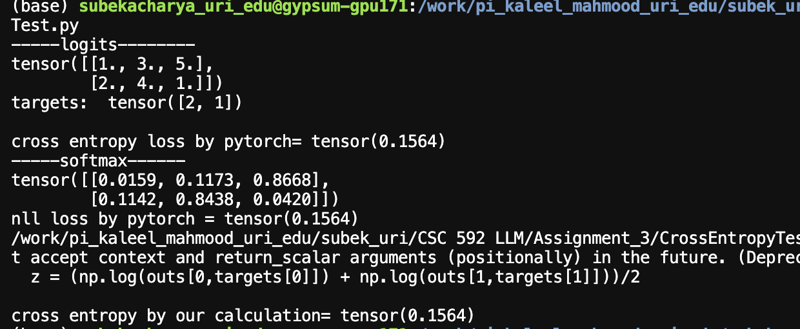

Question 11: Why can the ”torch.nn.functional.cross_entropy” function take in logits and produce the same output as “torch.nn.functional.nll_loss” in the above code?
- In nll loss function, first softmax is calculated which gives log probability which is then passed to the nll loss function where as in cross entropy loss function softmax is internally applied due to which we can directly send logits to the function. So, they produce same output.

Hint: It may be useful to look at the equations from the PyTorch documentation for the following three functions and compare what is happening:
- https://docs.pytorch.org/docs/stable/generated/torch.nn.LogSoftmax.html#torch.nn.LogSoftmax
- https://docs.pytorch.org/docs/stable/generated/torch.nn.NLLLoss.html#torch.nn.NLLLoss
- https://docs.pytorch.org/docs/stable/generated/torch.nn.CrossEntropyLoss.html

Deliverables
Submit the following two documents on Brightspace:
Deliverable #1: A document (pdf or word) with the answers to the questions.
Deliverable #2: A copy of your code (the .py files) as a zip file.

